How to Check MySQL Table for Errors

- Through a MySQL CHECK TABLE query.
- Using the terminal program mysqlcheck.
- MySQL CHECK TABLE query
CHECK TABLE <table name>;
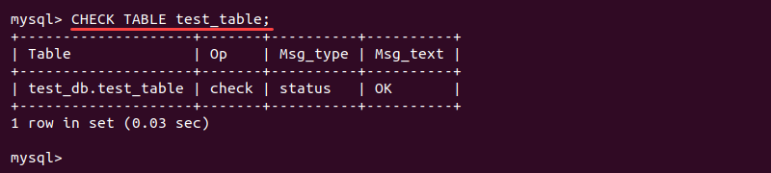

- Check a Table With mysqlcheck
As the root user, navigate to the directory where the databases are stored:
sudo su
cd /var/lib/mysql
Check the whole database with:
mysqlcheck <database name>
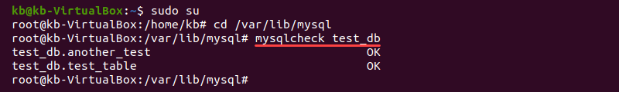
mysqlcheck <database name> <table name>

How to Repair MySQL Database

There are several methods how to repair a database in MySQL. However, keep in mind that these methods are not a quick fix and can result in data loss. If the database tables are corrupt often, identify the reason for the occurrence.
Before making any changes and starting repairs, create a copy of the directory:
cp -rfv /var/lib/mysql /var/lib/mysql_copy
Alternatively, make a backup version of the database before trying any of the repair solutions. Follow our guide:

Repairing MySQL Database with REPAIR TABLE Query
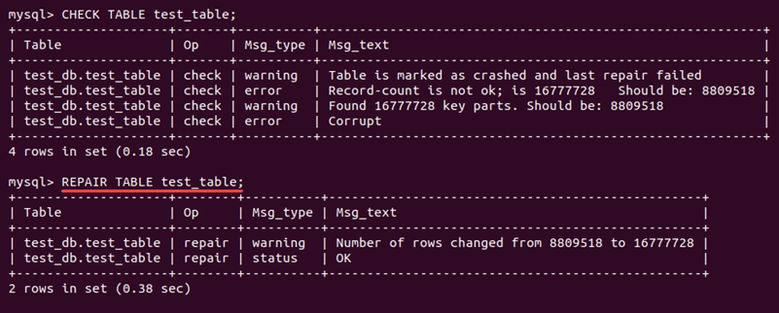

Repairing MySQL Database with mysqlcheck
1.First, navigate to the MySQL database folder as the root user:
cd /var/lib/mysql
2. Add the -r option to the mysqlcheck command to repair the database table:
mysqlcheck -r <database> <table name>
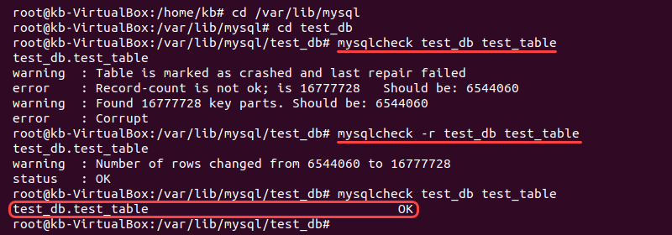

Use myisamchk for MyISAM Tables
it is use only for MyISAM Tables
myisamchk -r /path/to/your_table_name.MYI
Use innodb_force_recovery (for InnoDB Tables):
In MySQL configuration file (my.cnf):
innodb_force_recovery = 1
Set the value to a number from 1 to 6 (higher numbers are more aggressive in recovery). Restart the MySQL service.

